# Some points for your group assignment web page:

## How to add image and video

In edit mode of the body of the page you should see these icons:

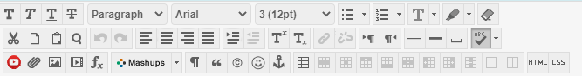

If you can’t see all tools, please click on:



Then you will have full tools. You can add images (pics) and videos by using following icons:

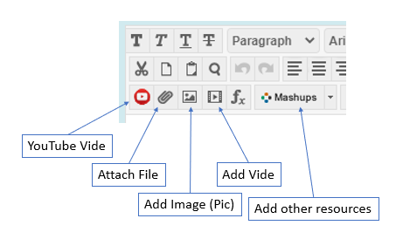

## How can I add HTML and CSS codes?

You don’t have to do any coding. However, there were some emails to do some coding in this assignment. It is possible by clicking on these icons:

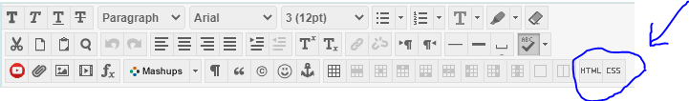

Again you don’t need to write any code.

## How to share the page with the professor?

Please follow the instructions:

When everything is ready to share, go to the main page of Portfolio Homepage and click on:

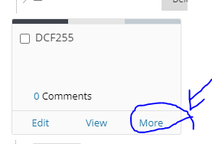

Instead of DCF255 at the picture, you should have your webpage title name. Then click on share:

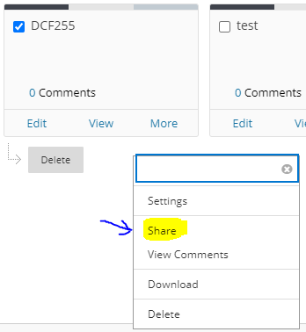

Then on the share page, you need to click on the drop-down menu left-hand side of “Share a Snapshot with” and choose “User”:

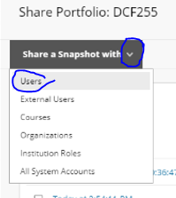

Then just put your professor username (like Majid.Shahravan), and it will share your page with Professor’s Portfolio Homepage. Please send an email to the professor to make sure the system shared it with your professor. Please, in email, provide your section and group number.